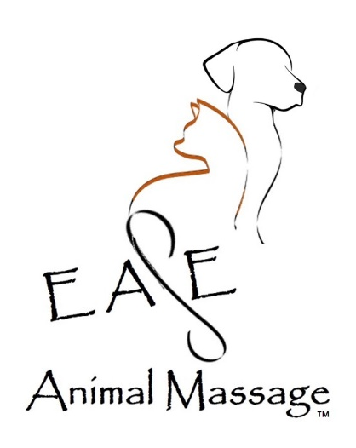
Informed Consent and Disclaimers:

Statement of Disclosure:
Elizabeth Fey, CPMP is not a veterinarian nor will she diagnose medical issues, offer medical advice, prescribe drugs or perform surgery. She is a massage/touch therapist, incorporating massage techniques to provide individualized therapeutic bodywork to dogs and to cats. She has been providing this service since 2017. Your animal(s) will receive gentle, compassionate care based on the knowledge gained through this experience and courses taken in these modalities and animal communication. The role of the CPMP is that of a facilitator, assisting your animal(s) to attain or maintain a naturally healthy state.

Consent and Acknowledgement of Treatment/Therapy:
I, ______________________ have read and understand the above disclosure statement in regard to the treatment/therapy to be given to animal(s),____________________ , by Elizabeth Fey, CPMP – EASE Animal Massage™. I understand that this practitioner is not a veterinarian, and that the treatment/therapy given is not to be considered as veterinary medical treatment and that the comments, suggestions, or recommendations proffered in the course of this treatment/therapy are not to be considered as veterinary medical advice.

I, ______________________ hereby wish that my companion animal, ________________ to receive animal massage treatment/therapy and give my consent and acknowledgement by signing below.

Signature: ___________________________________________
I confirm that am 18 years or older:

Date: ___________________________________________
Address: ___________________________________________
City/State/Zip: ___________________________________________
Phone: ___________________________________________

